To Install our SMS Plugin on vtiger, we have to follow mention below Steps. Before preceeding we have to download the Zip file from Link:

https://github.com/jain640/Vtiger_SMScountry_plugin

Save the zip file in folder.

Step 1: Open the Vtiger in Browser, go to the Setting Menu as shown Below:

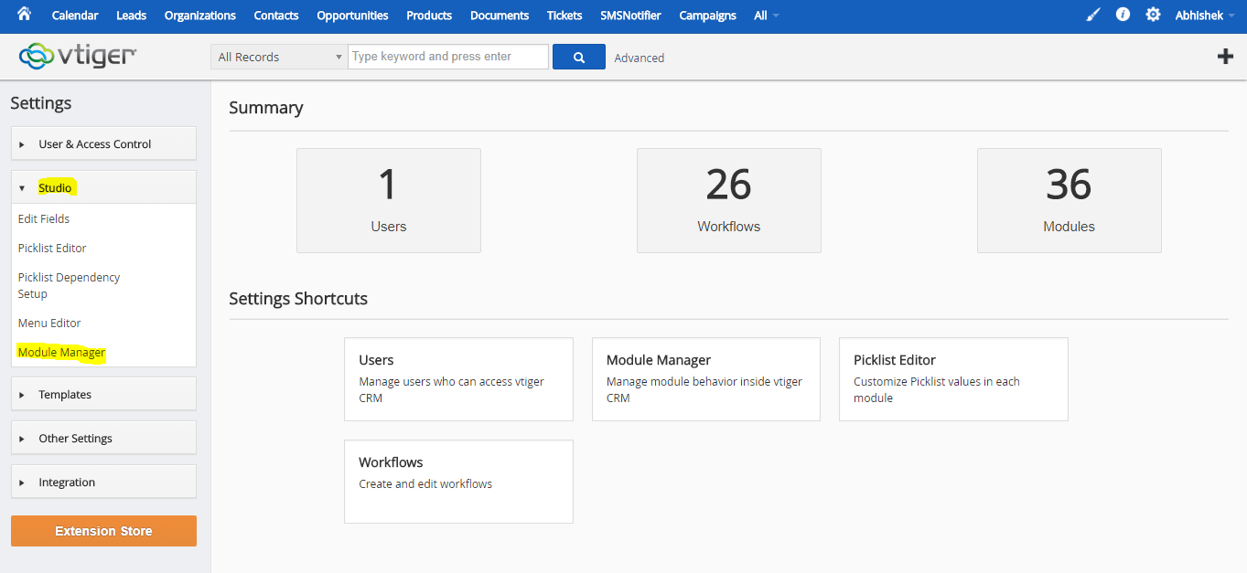

Step 2: Select the module manager, scroll to bottom of page and click “Install from Zip”.

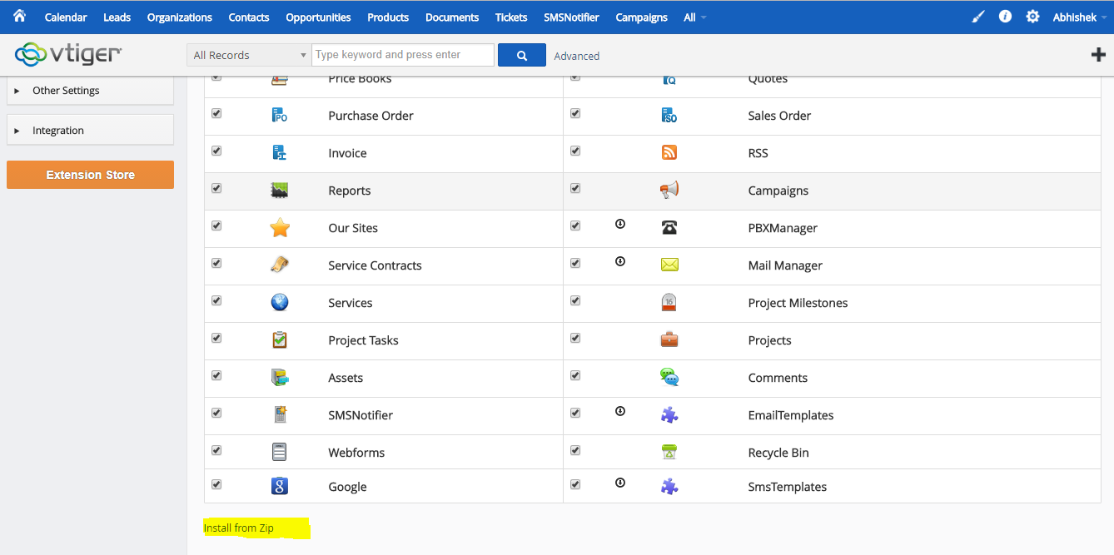

Step 3: click on choose file and select the zip file you have downloaded and selection click on import.

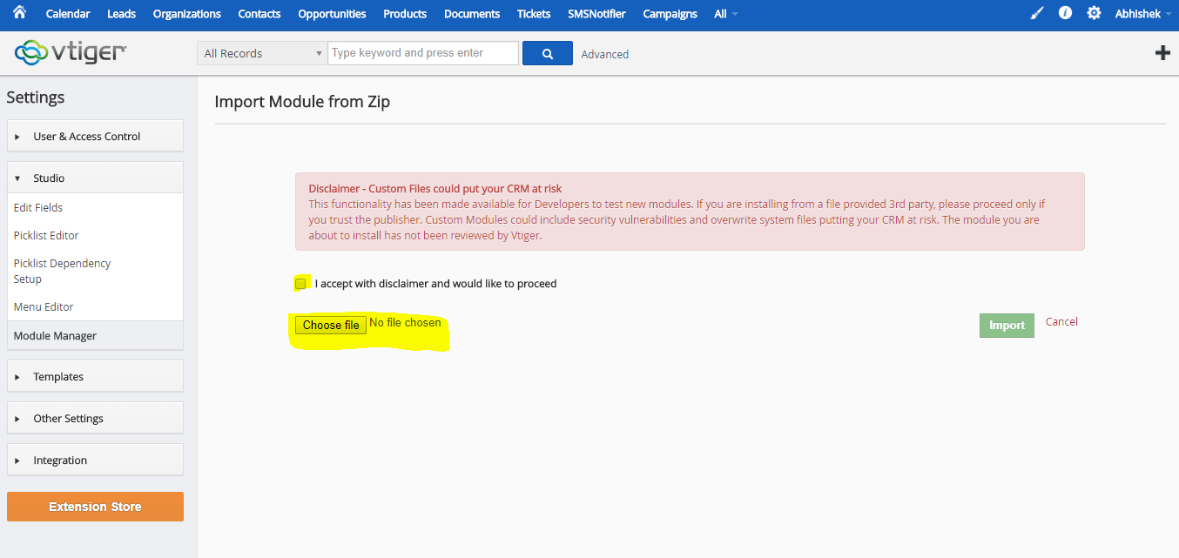

Step 4: click on install button if you are reinstalling it will show the Update button in place of install as shown below:

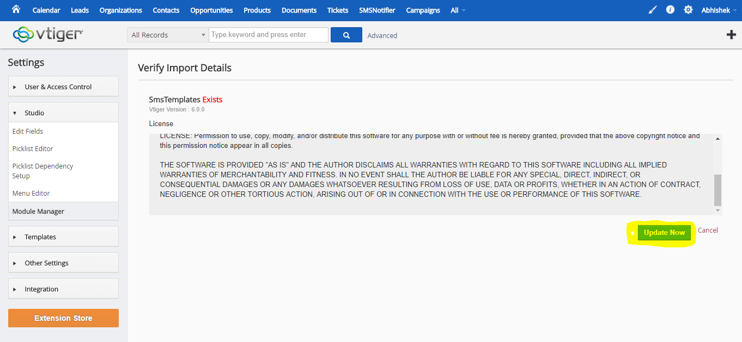

Thanks you SMS Plugin is installed,

Step 5: To send the SMS using this plugin you need to get touch with SMS Country to know you credential. After getting credential you need to setup as mention below:

Step 6: Kindly goto the SMS Notifier, click on Setting button under it, as mention below:

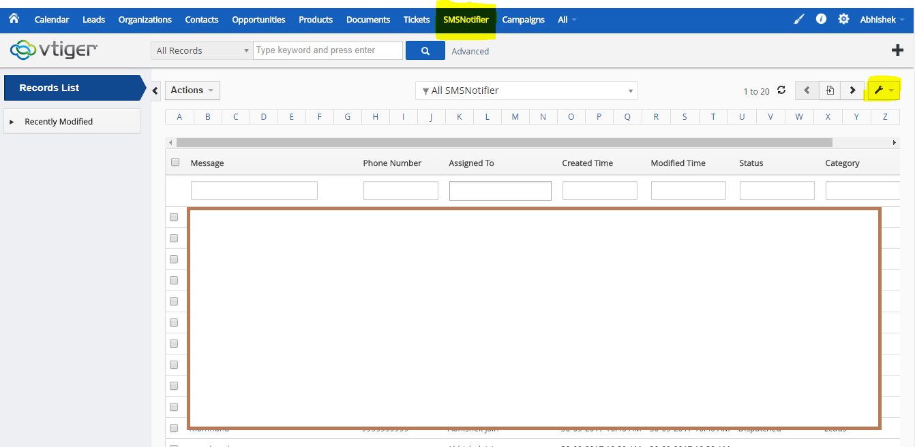

Step 7: Choose the Server Configuration as mention below:

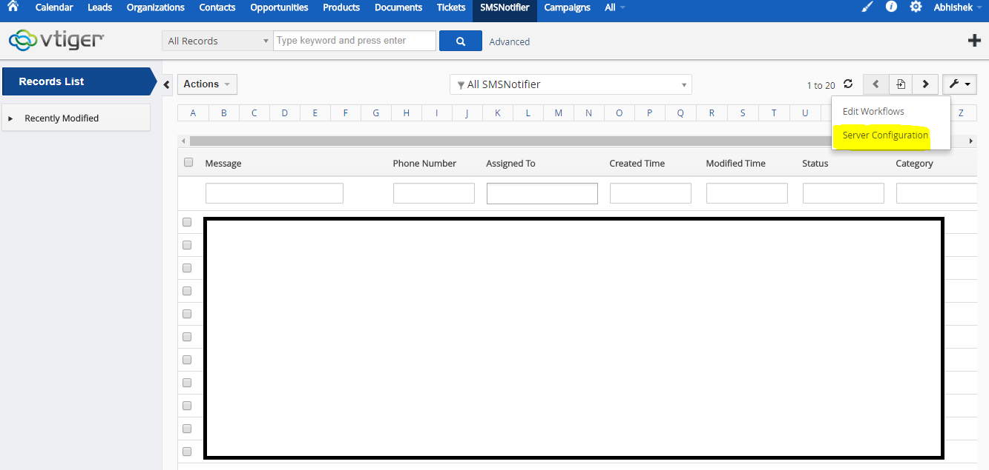

Step 8: Click on New Configuration to Add new credential, or select the existing one.

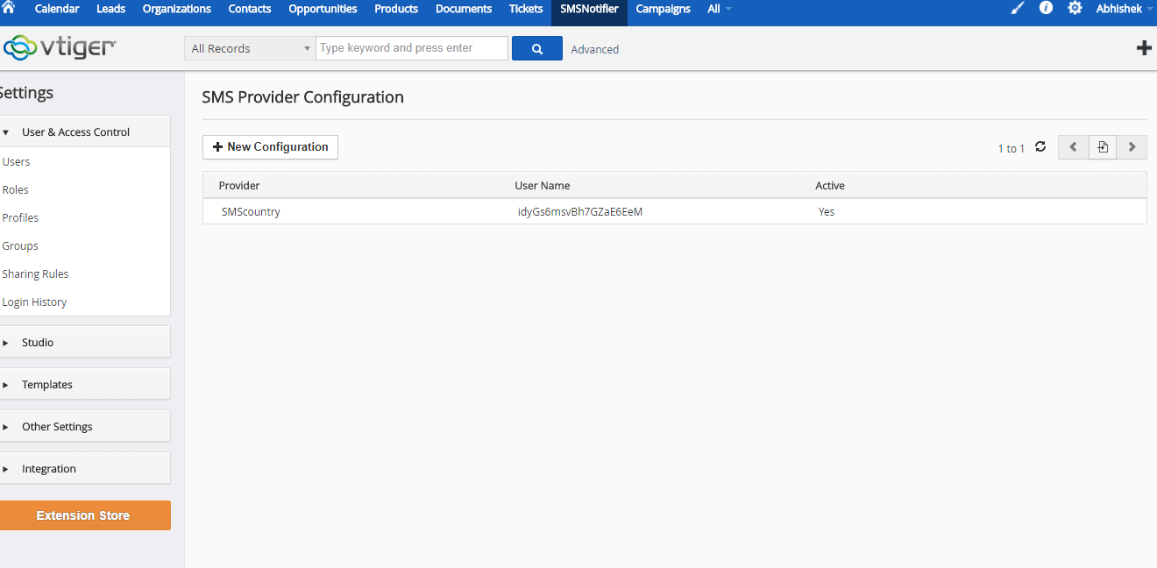

Step 9: After click on New Configuration, please fill the as shown below:

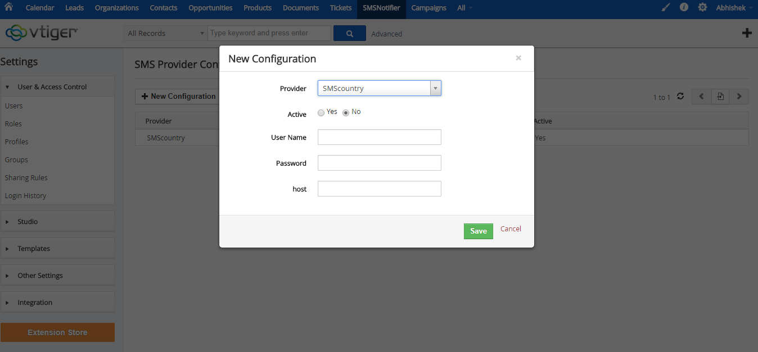

Thanks, now you can send SMS using SMS country API through different module like: Leads, Contact and Campaign.